Organic
Aquaponics

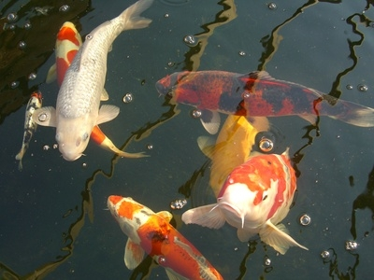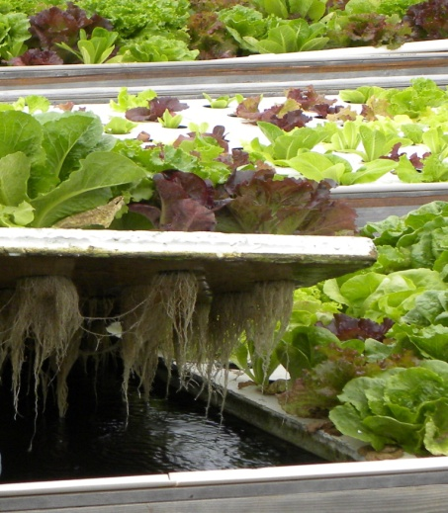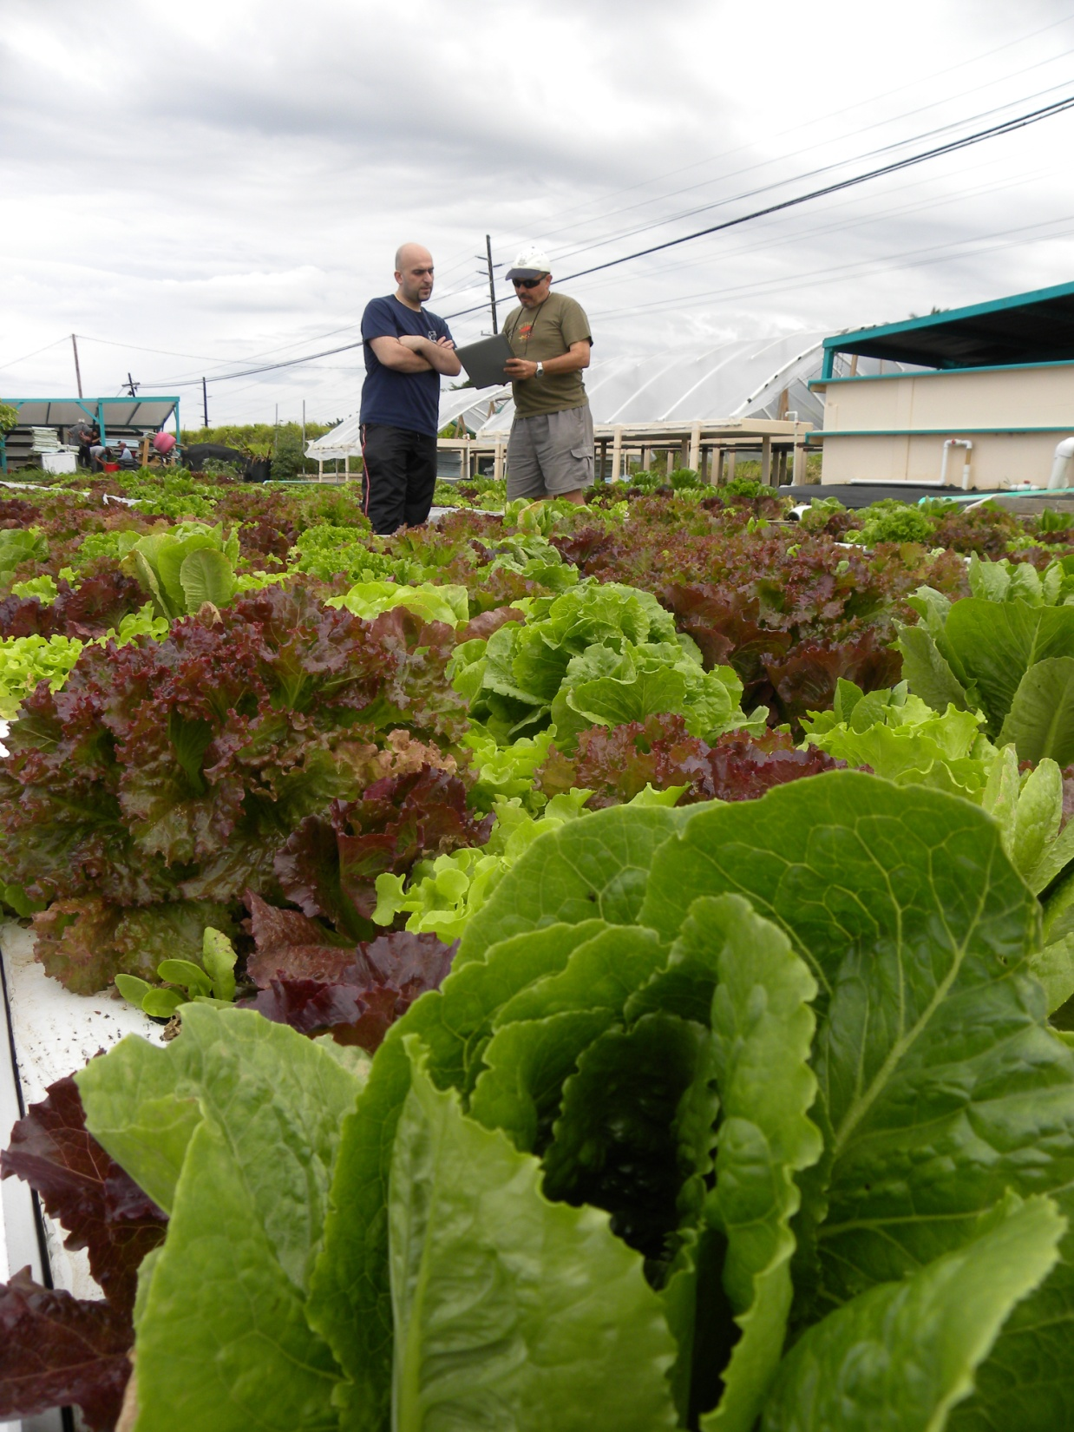
Fresh, Healthy, Sustainable
Organic Aquaponics
Executive Summary
Aquaponics Mission - Aquaponics is a method of food production which combines the best aspects of aquaculture and hydroponics to create a highly productive living ecosystem for sustainable agriculture. Organic Aquaponics seeks to bring aquaponics to our local market through the use of commercially viable strategies to grow nutritious vegetables using the most sustainable agriculture systems available.
Problem- Today, agriculture is much different than that practiced by our grandfathers. Threatened by problems related to water shortages, topsoil loss, reliance on fossil fuel inputs, and a changing climate, the productivity and reliability of our food systems and ecosystems are at stake. Alternatives are needed which are more efficient in use of resources, sustainable, resilient, and better mesh with our communities. Aquaponics is an agricultural technique poised to meet our current and future needs for locally raised, healthy and sustainable produce.
Market- There is a growing and diverse clientele for healthy, local, and delicious vegetables. Within the greater Tri County area, we will supply a range of crops to our community through sales to produce distributers, specialty markets, local farmers markets, and Community Supported Agriculture (CSA) farms.
Competition- Currently, many competitors exist who sell organic and conventional leafy greens. Market differentiation can be demonstrated by showcasing the great taste of aquaponics produce, the ‘living’ produce we will sell which stays fresh longer, and the sustainability of aquaponics agriculture. By focusing on local and regional markets, we will provide superior produce within our community and expand the crops available within the living produce niche.
Potential- The potential for aquaponics to capture a large share of the fresh produce market in any one location will be difficult, due to the extensive and established food distribution network. However, similar to an electrical grid which relies too greatly on far off electricity sources, the inclusion of local and sustainable supplies is desirable to consumers and local economies. Organic Aquaponics plans to supply the growing market share for the seasonal vegetable demands of local communities with an aquaponics system which is both water and energy efficient, and requires minimal inputs. This resource efficient and cost effective alternative to traditional agriculture is well positioned to advance to commercial production. Aquaponics has faster production cycles and increased planting densities compared to traditional agriculture, providing aquaponics a distinct advantage moving forward.
Goal- Organic Aquaponics goal is to grow healthy food for our region, optimize water and energy efficiency of aquaponics operations, demonstrate the commercial viability of aquaponics farming, and promote the sustainability of aquaponics as an alternative to existing food production systems. We will strive to educate others as we develop techniques that are scalable from backyards to large commercial farms in order to lighten the impact of modern agricultural practices.
Organic Aquaponics
Business Plan
General Company Description
Aquaponics is a method of food production which combines the best aspects of aquaculture and hydroponics to create a highly productive living ecosystem for sustainable agriculture. By cultivating fish and plants in a re-circulating system, fish waste can be converted to plant food using natural bacterial cycles. Organic Aquaponics seeks to utilize cutting-edge aquaponics techniques to grow organic vegetables for our community, educate others about aquaponics potential, and demonstrate the sustainable nature of our aquaponics food production.
History- Aquaponics is most well known in Australia, where recent droughts have transformed the way water is used. Aquaponics though has its earliest roots in ancient Mayan traditions which combined fish ponds and crops which grew on rafts floating above the fish. Recent advances in aquaponics have improved the overall system productivity, reduced water use and resulting waste water pollution, and improved nutrient cycling, all of which vastly improve the sustainable nature of the practice. While there are still advocates for many different methods of aquaponic production, deep water raft culture has shown significant advantages for many crop species in production density, labor requirements, and overall simplicity over gravel bed systems, nutrient film, and other techniques.
The practice of aquaponics is experiencing significant growth among backyard gardeners and permaculturists as they embrace the opportunities of space saving and sustainable food production. Commercialization at this time has been limited despite the incredible opportunity it presents and the improved economy of scale it offers over the more common backyard systems. By producing high quality and nutritious vegetables in amounts 8-10 times greater than in soil, we believe aquaponics presents tremendous opportunities for commercial and urban farmers.
To ensure the success of Organic Aquaponics, we will establish a highly productive and stable ecosystem and demonstrate the superior taste and shelf life of aquaponics vegetables in order to differentiate ourselves from traditionally grown produce.
Balanced Ecosystem- The underlying key to aquaponics system stability and production is maintaining a proper balance within the living ecosystem between fish feeding rates (inputs) and plant uptake of nutrients (outputs). Similar to organic farmers who nurture the soil to ensure the ideal nutrient balance plants require, aquaponics systems must achieve a balance between nutrient availability to maximize plant growth and proper water quality for the fish, bacteria, and plants within the system. To effectively maintain nutrient balance, it is important to balance the ratio of pounds of fish to plant grow space, achieve efficient nutrient cycling, and continually start new vegetables to replace harvested produce.
The ability to use rapidly growing vegetables as a form of filtration for fish waste is a game changer for the idea of sustainable aquaculture. Even today, most aquaculture operations waste a tremendous amount of water in order to dilute the nutrients which build up in the system. Aquaponics systems rely on micro-organisms which convert dissolved and solid fish wastes into forms readily available to plants, preventing the buildup of nitrate and eliminating the need for regular water changes to maintain fish health. This efficient nutrient cycling possible by combining aquaculture and hydroponics results in a stable and incredibly productive ecosystem without the high water use and waste water pollution typical of aquaculture. Furthermore, aquaponics avoids the nitrogen loss from soil to runoff and percolation into the ground, preventing contamination of surface and groundwater.
Organic by Design- Organic Aquaponics will follow closely in the footsteps of the pioneering work of Friendly Aquaponics, located on the Big Island of Hawaii. After attending the Friendly Aquaponics commercial aquaponics training in 2011, we have gained the right to use the same materials and system design which has proven commercial success and can be certified organic. While the substantial water savings, efficient nutrient cycling, and other sustainable methods we will use are marketable, the organic label is what the customer trusts and what allows farmers to charge a premium price for our quality product.
Market Differentiation- It will be important to establish differences between our products and existing local organic and ‘living’ produce. While traditional organic or hydroponic farms offer significant improvements on modern industrial agriculture, Aquaponics goes further towards addressing sustainability of food systems thanks to the benefits of organic and hydroponic production. To define our sustainability, it will be important to document how aquaponics reduces water and energy use, highlight the incorporation of renewable energy to maintain ideal water temperature, and perform a carbon footprint and/or Life Cycle Analysis on aquaponics. The goal is to prove to industry and the consumer the sustainable nature of aquaponics.
Existing aquaponics farms highlight the superior taste and shelf life of their produce. Since we will be using the same materials and methods of Friendly Aquaponics on Hawaii, a commercially successful organic aquaponics farm, we have every reason to expect improved taste and shelf life compared to traditional produce.
Marketing- Aquaponics methods of growing food are not yet well known by the general public. Therefore, we do not expect large initial sales volumes at the retail level. While we do expect to raise delicious produce, initially it will be important to build relationships with wholesale produce markets who understand our value and unique niche we fill. Initially, we expect them to be our largest customers and partners in gaining market exposure. For retail sales, we envision promotions to get customers to taste the difference between aquaponics and regular produce in order to secure an initial sale which can establish customer loyalty. Regular exposure at Farmer’s Markets and securing valuable shelf space at supermarkets are critical to making the first connection with customers, after which we hope the product quality will speak for itself. Likewise, the creation of a logo which simply explains the unique nature of aquaponics will be important for defining what is Organic Aquaponics.
Customers- Initially we plan on establishing relationships with wholesalers to focus our energy on build out and refining the production process. This will be very important to ensure an initial revenue stream and quickly ramp up sales volume. While volume sales at the wholesale level are important, significantly less revenue is generated per item produced. By month 6, we will establish relationships and contracts with grocers, and Farmer’s Market customers to capture a larger percentage of the non-wholesale market. Currently there is a waiting list for some of the better Farmer’s Markets in our county, but the unique produce and approach of Organic Aquaponics may allow us to obtain prime space and better retail volume and exposure. As our products become established with the community and retail sales expand, we will be able to earn more revenue per unit.
Location- The abandoned ABC Company greenhouses are in the process of being transformed from a nearly abandoned row of greenhouses to a vibrant farming community. Anchored by Farmer’s Wholesale Produce, a sustainable produce distributor, numerous greenhouse bays are being revamped for organic farming operations and plant research through the University. This facility offers an excellent physical platform to cost effectively build a commercial organic aquaponics facility. Greenhouse bays are roughly 10,000 ft² and upon project initiation, we will secure an option on adjacent greenhouse bays for possible expansion should market conditions and growth projections allow.

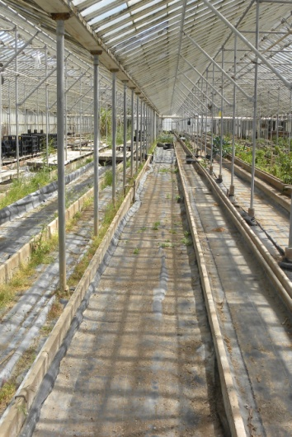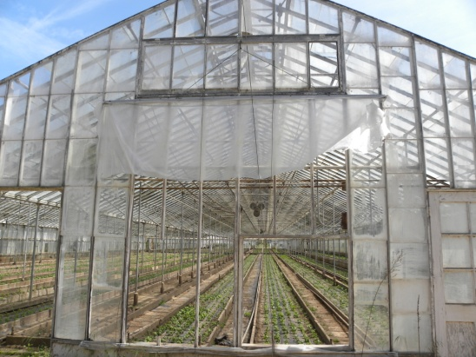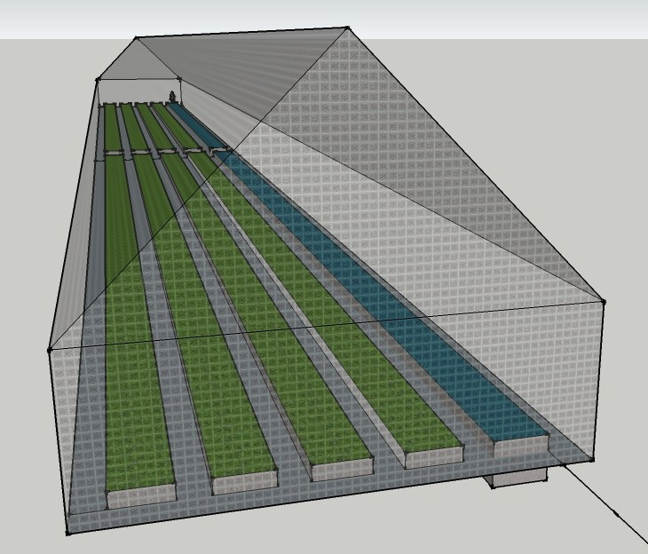

Products and Services
Fish- Aquaponics grows both fish and vegetables but to the majority of people, the fish are seen as the most intriguing and valuable side of aquaponics. It turns out that for Friendly Aquaponics and other aquaponics farms, over 90+% of revenue from vegetable sales thanks to the fast growth of plants and large market for organic vegetables. We envision the value of fish primarily as the ‘engine’ to provide balanced organic nutrients to the vegetables and will manage our fish stocks for growth in the first few years to allow system expansion rather than sales.
We plan on utilizing koi as the main fish species within the system and believe they are ideal due to their tolerance for variable water quality (especially seasonally cold temperatures), rapid growth, ease of breeding, and marketability within the local ornamental pond market. To offset high initial purchase costs for koi, we will purchase ~1000 2” koi from local breeders, enough to begin operation of two troughs. As the fish grow, the number of pounds of fish in the system grows, providing the nutrients necessary to connect more troughs and scale up the vegetable grow area as we maximize organic vegetable production. As we scale up, we will separate some koi for future brood stock and sell a limited number with good markings but keep the vast majority for our fish ‘engine’. Only after successful breeding and rearing of koi and expansion of the aquaponics system has occurred, will we begin a larger scale marketing of koi, likely at the end of year two. Once fish sales begin, we feel our koi will have an inherent advantage as unlike other commercially available koi, these fish will have been part of an innovative and sustainable agricultural venture and raised in local water quality conditions.
Vegetables- The majority of expected revenue will come from the organic vegetables we produce. Fish produce a nearly continuous source of dissolved nitrogen in the form of ammonia, which is readily converted to the available form nitrate. These nutrients are continuously available to plants as water flows past their roots, enabling plants to grow faster than they could in soil. Aquaponics has a faster time to harvest, resulting in more harvests per year. Combined with the higher crop densities possible with raft culture, each square foot of raft grow out space can annually grow 8-10 times the amount of vegetables in soil. For these reasons, we will maximize raft space for vegetables to achieve larger production and an excellent return on investment.
Our use of deep water culture aquaponics systems can produce a wide range of crop types but leafy green vegetables and small herbaceous plants have been shown to be ideal in these types of systems. These plants, which are harvested before flowering, benefit from the stable nitrogen levels fish provide in aquaponics systems. Flowering plants such as tomatoes, peppers, broccoli, etc., prefer a shift from nitrogen inputs to phosphorous and potassium inputs when flowering, which is difficult to manage if these are the dominant crops in an organic aquaponics system. While we plan on growing a variety of vegetables, including some flowering plants, our plan focuses on leafy green vegetables and other similar nitrogen loving plant species which have proven to thrive in raft aquaponics.
By year two, we will to create value added products as an important area of growth for Organic Aquaponics. By partnering with local chef’s and renting commercial kitchen space, we can use many crops we grow to make other products, such as pesto and dressings, kale chips and flakes, and many other possibilities. Careful consideration of value added products can become a highly profitable line and make good use of peak season harvests.
The greenhouse space we are considering will be significantly larger than we will initially convert to aquaponics. In order to allow our juvenile fish to grow and prove the system design works for our location, we will have some space where we plan on growing vegetables using traditional methods. This will be a good method for us to generate revenue in years one and two with minimal capital expenses. Over time, as we confirm aquaponics system design and expand the system, the area available for traditional soil crops will be phased out to allow for more profitable aquaponics operations.
Living Produce- A recent trend in the produce aisle has been the marketing of ‘living’ hydroponic produce. Mostly butter lettuce and basil, they are sold with roots still attached in a plastic clamshell container to protect the produce and maintain humidity and root health. By purchasing vegetables with the roots still on, the consumer receives a product with improved shelf life and product quality, an important advantage in the perishable food industry. This new niche for leafy greens, pioneered in the mostly non-organic hydroponic industry, can be easily harvested and marketed as a living organic product.
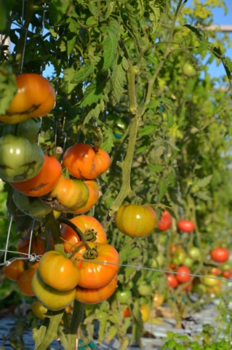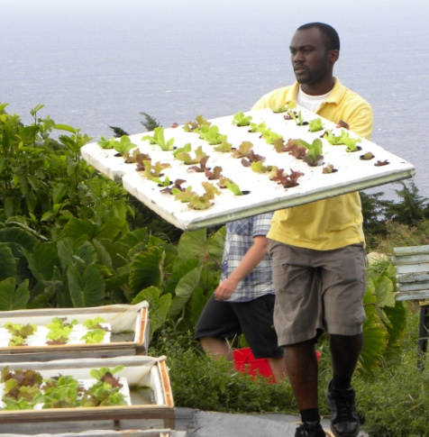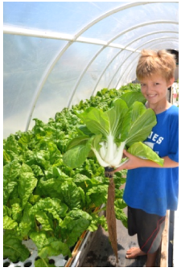
Renewable Energy- To produce optimal growing conditions year round, maintaining water temperatures around 72° F has been shown to be the most important environmental factor besides light availability. To accomplish this, we will utilize an existing greenhouse, insulated tanks, solar thermal water heating, and ground source heat pumps. The use of insulation and renewable energy to heat and cool water will help maintain these optimal conditions with significantly reduced reliance on fossils fuels such as natural gas or propane. We anticipate these actions will extend our growing season and give us a market advantage over our local competitors. We expect our results will demonstrate our leadership in sustainable agriculture while also improving our bottom line.
Greenhouse Management- Greenhouses provide an effective method to control environmental conditions and improve plant growth and extend growing seasons. Proper operation of a greenhouse is critical to ensure temperature, humidity, light, and other factors match crop needs. Existing greenhouses at the ABC Co. have manually operated ridge vents and large openings on either end for cross ventilation. Unlike standard greenhouse operations, our system will involve over 50,000 gallons of water within the troughs, which will act as a very large thermal mass to minimize daily temperature extremes for the fish and plants roots. We will employ air and water temperature monitoring employ strategies which will maintain ideal growing conditions and which work best for our specific crops and the particular season. Similarly, we will actively monitor for and manage pests in order to reduce the frequency and severity of pest infestations within our controlled greenhouse environment. Put simply, we will employ good design, perform careful observation, and take swift action to maintain ideal environmental conditions for our crops.
What’s in a Name- Organic Aquaponics strives to live up to its namesake both in what we produce, and the lifestyle of our target customers. The ability to greatly expand into the organic produce market makes Organic Aquaponics immediately recognizable among our competitors. Our Organic certification will be ingrained in our business name, showcasing the phrase most understood by consumers to symbolize a better and more sustainable product. And Aquaponics will proudly recognize and educate consumers to this innovative approach to sustainable agriculture. While aquaponics is virtually unknown to the average consumer, we anticipate once they have had the ability to taste our produce, aquaponics will be recognized as a superior method to grow a wide range of vegetables. Organic Aquaponics will connect with the lifestyle of members of our community who want the freshest and most delicious produce, care about what they put in their own body, and promote the health of their community and planet. Our goal of promoting Organic Aquaponics as a lifestyle choice can help our customers affirm how their purchasing decisions can positively impact the social, economic, and environmental issues they care about.
Competitive Advantages and Disadvantages- For wholesale distributors and retailers, the competitive advantages of our products include being a desirable local organic product; produce which requires less lead time for requests since vegetables grow much faster than in soil; and our ability to provide living produce they do not currently have access to. Competitive advantages for the consumer include the delicious taste of aquaponic produce, the availability of ‘living’ produce which improves the shelf life of the produce in their fridge, and the organic certification and superior sustainability of our product.
Aquaponically grown produce has been found to be much sweeter and less bitter than crops grown in soil or hydroponic solution, resulting in a significant taste advantage which is critical for repeat sales and marketability. We will seek to capitalize on this through taste tests with locally available products and if significant, prominently feature taste testing at Farmer’s Markets. While a few firms offer living butter lettuce or basil, they use hydroponic methods which are not certified organic and are not part of a larger ‘living’ product line. Many other local competitors sell organically certified produce but none using aquaponics techniques. As knowledge and demand for aquaponics produce grows, we feel the customer will seek out our products which have a longer shelf life, great taste, and are organically certified.
Risk Management- Many things can go wrong with traditional farming and aquaponics similarly has risks. Risk management is essential to long term success by reducing the likelihood, frequency, and 77severity of risks. Our plans take into account good system design, climate control, backup pumps and generators, security, organic pest management, keen observation, and a rapid and appropriate response to emerging problems all will play a role in preventing and limiting damage from known risk factors. We will be using aquaponics methods and materials with demonstrated commercial success and which emphasize energy efficient and labor efficient design, allowing us to minimize ongoing costs and reduce the risk of the unexpected.
Potential risks for an aquaponics operation include loss of fish or crops to pests, disease, or vandalism; plumbing or equipment failure resulting in system leaks or water quality emergency; changing markets or competition; loss of key staff or partners; or problems with permitting, health code violations or other regulatory problems. While these risks could lead to either potential short term revenue loss or in some cases more substantial problems, our team will actively consider these risks and continually evaluate other risks and threats to the operation. We plan on operating in a financially conservative manner to ensure adequate operating capital to provide flexibility to respond to changing market or other conditions.
Pricing- Our products will be priced competitively with locally available organic produce but offer the advantages of superior sustainability, taste, and shelf life. For sales to restaurants and schools where products will served as parts of a meal, live sales will not be necessary as the purchasing will be done frequently enough where living produce is not necessary. For these customers, we will be able to reduce costs with the use of traditional single cut practices which will simplify processing and avoid the use of individual plastic bags for each head of produce which is necessary for ‘living’ produce.

Marketing Plan
Market Research- Marketing for the primary product, living organic produce, will be done through discussions with wholesale produce distributors, grocery stores, and community groups such as school districts. We will seek to find the best balance between time consuming sales direct to consumers and retailers vs. the ease of selling to wholesale produce distributors, such as the onsite Farmer’s Wholesale Produce.
Target Market- Our target market includes eco-conscious consumers who desire fresh, local, and organic products. They desire healthy food, less chemicals, and more appropriate use of resources. This demographic is 25-64 years old, has an income above $50,000, and is socially aware. According to data from the U.S. Census’s 2005-2009 American Community Survey, 184,351 people in live in our County, or 46% or our target market are between the ages of 25-64, and 80,804 households, or 58% of all households make over $50,000. Based on the available data of age and household income, and the general success of many environmentally and socially minded organizations locally, our locality appears to be an ideal location for Organic Aquaponics. In addition, our proximity to large markets the Tri-Counties allow room for significant growth through existing distribution networks if local markets cannot support our growth potential. Combined with living produce’s extended product shelf life, we feel the unique attributes of Organic Aquaponics vegetables will provide our customers with a more desirable but competitively priced alternative over traditional produce. We expect our emphasis on raising the bar for sustainability will create excellent product recognition and improve our ability to secure repeat sales.
Market Trends- Our broad target market of consumers seeking organic food had sales quintuple nationally from 1997 to 2008, from $3.6 billion to $21.1 billion, as seen in Figure 1. This amounts to 3% of total U.S. food sales in 2008^{i} but in communities such as ours which are health conscious and affluent; this percentage is likely much higher than 3% of the market. A recent survey in our county revealed a majority of respondents said it was important to buy local produce and nearly half said they purchased local produce at least once a week. As consumer awareness of the harm caused by pesticides and herbicides grows, the market demand for organic and other more sustainable attributes has increased. We aim to take advantage of this demand growth and help meet the need for healthier food for ourselves and our planet.
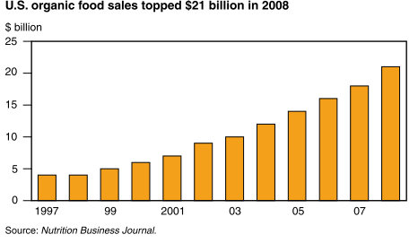
Figure 1. U.S. Organic Food Sales from 1997 to 2008.
Healthy Food- The leafy green vegetables we will grow are some of the healthiest on the planet, and thrive in aquaponics systems. These vegetables are nutritionally dense, and score at or near the top of the Aggregate Nutrient Density Score (ANDI), a general measure of how healthy food is. We will promote healthy food choices and counter the growth in diet related diseases such as obesity and diabetes. We are committed to working with community groups and schools to ensure additional healthy and sustainable food choices are available to those who need it most.
Promotions- Because we will be selling a product which is similar to the produce consumers are currently purchasing, promotions will be important early on to get customers to try our produce. Free taste tests comparing our produce to soil grown produce and providing free samples to customers will let consumers taste the difference and give us time to tell them why our produce is better. These promotions are intended to raise customer awareness of our new products, encourage customers to try our products, and incentivize repeat sales.
Education- Aquaponics offers significant potential to help our society grow food both commercially, and in our backyards. Organic Aquaponics wants to help spread the word about aquaponics by offering trainings, workshops, and demonstrations to farmers, regulatory agencies, schools, and the general public. We expect our operation to be a living laboratory and hope we can share what we learn with others in a way that lets aquaponics grow into something greater. We plan on pursuing grants to help support our effort to education and train others in the methods of aquaponics food production. Only together can we move sustainable agriculture forward.

Operational Plan
Organic Aquaponics will grow fresh produce in climate controlled greenhouses on the South Coast of our county. This location will provide a year round growing season where cool ocean breezes hold the hot summers at bay, providing a significant advantage to growing cool season leafy green vegetables year round.
The physical location of our facility will be a ~10,000 ft² greenhouse within a large greenhouse complex located on Ranch Road. The hours of operation will typically be from 7 AM to 4 PM Monday through Friday with minimal operations on the weekends but is dependent on workplace needs and production requirements. Since this is a production facility and not a retail outlet, the public will not be present at this facility except when tours or workshops are offered. The greenhouse will be leased under a standard agreement with the ABC Company. This space will be leased at $0.65 per square foot per year with a 3% annual increase.
Labor requirements for construction depends on the size of the initial system and final construction plans but is expected to be coordinated with substantial volunteer labor. Ongoing labor will depend on the ratio of wholesale vs. retail sales, eventual efficiency of operations, and other factors. Proper management of the operation requires knowledge of fish husbandry, systems operation, and plant cultivation. Plant health will need to be addressed carefully using Integrated Pest Management strategies since the use of traditional pesticides and herbicides may kill the fish within the system.
Much of the work in aquaponics, like in traditional farming, will revolve around repetitious steps in the plant production process. Our system will utilize 2’ x 4’ Styrofoam rafts for growing crops, with each raft containing 30-60 holes for net pots and plants. These rafts are light and can be easily lifted out of the water and placed on portable work stations at waist height for transplanting and harvesting. Compared to soil farming where most of the work is done at ground level, aquaponics will significantly improve working conditions and reduce workplace injuries. Ergonomics are improved during the steps of initial planting, transplanting to grow out rafts, removal of diseased or dead out leaves, and final harvest and processing. Additionally, the troughs act as a conveyor belt, where as rafts are harvested, space is created for all the other rafts to be floated down, creating space for new rafts with young plants at the other end of the trough. This arrangement creates harvesting and transplanting ends for each trough and will greatly reducing time and energy spent carrying harvested vegetables long distances from the field to process.
We expect to begin operations with a single project manager on full time staff, some part time staff to assist with seeding, transplanting and harvesting, and plant specialists available as needed in an advisory role. By actively recruiting both State University and City College students as interns, we feel Organic Aquaponics can be a unique environment to educate and involve those interested in a truly innovative approach to sustainable agriculture. Significant knowledge and experience will be required to establish the system and develop procedures for day to day operations. Checklists will be created to ensure regular maintenance and tasks can be performed with minimal skilled supervision. It will be critical for employees to be observant so we can quickly address any problems with plant health, insect and pest outbreaks, changes in flow or aeration, fish behavior and appearance, and environmental conditions in the greenhouse and water.
Initial materials will be sourced through both local and internet based suppliers. Hardware and other construction materials will be purchased through local stores wherever possible while the bulk of the aquaculture related supplies will be sourced through Aquatic Ecosystems in Florida.
Maintaining plant inventory is critical to ensure enough plants are always in production to meet existing and future orders. In addition, the system should always have some mature plants, which have extensive root surface area where beneficial bacteria can colonize to achieve proper nitrogen cycling. While proper crop rotation is typical for all agriculture, the rapid growth of plants in aquaponics systems creates a shorter interval between seeding and harvest and thus allows less lead time in crop management decisions. Inventory will be assisted by numbering rafts and organizing each to include only one plant variety and age, improving the ability to track plants age and count large quantities of plants which will move through the system. These methods will assist in crop management and also in understanding seasonal changes in growth rates for each plant type.
Management and Organization
Organic Aquaponics has assembled a management team of skilled staff, industry experts, and professionals.
Fill in related experience here of major players in your business
President -
Vice-President -
CFO -
COO -
Etc.
Additional Staffing- As a business on the cutting edge of sustainable agriculture, we are devising a model which will offer interns the opportunity to gain experience, learn state of the art farming principles, receive a share of marketable produce, free attendance at formal workshops and trainings, and a profit-based stipend. By locating two miles from the State University, we are positioned to become a learning center for students extended education. Because many tasks within a commercial aquaponics operation are repetitive and simple, the use of interns is easily incorporated within the business. While traditional low wage agricultural workers are also a possibility, the unique nature of the business model will be best served by creating opportunities for those most interested in innovative sustainable agriculture and not just a job in the field. We at Organic Aquaponics are ready to help interested members of our community show there are alternative methods to grow fresh, healthy, and sustainable produce, all without a pinch of soil.
Start-up Expenses and Capitalization
Opportunity- Organic Aquaponics is seeking partners and capital investment of $75,000 to make our project a reality. This opportunity to become a partner in a showcase for a new sustainable food paradigm will help drive innovation in California agriculture, demonstrate food can be produced using fewer resources, and help support the expanding model of the local food movement. Join us, and join the food revolution.
Expenses | Year 1 | Year 2 | Year 3 | Year 4 | Year 5
 | 1/2 Greenhouse | Full Greenhouse | Full Greenhouse | Full Greenhouse | Full Greenhouse
Troughs | $7,752 | $7,752 | $0 | $0 | $0
Hardware Subtotal | $1,220 | $1,220 | $0 | $0 | $0
Pumps and Heaters Subtotal | $4,704 | $4,104 | $0 | $0 | $0
Plumbing Subtotal | $1,222 | $1,222 | $0 | $0 | $0
Misc. Subtotal | $1,600 | $1,450 | $2,122 | $2,185 | $2,251
Fish Subtotal | $5,975 | $800 | $1,273 | $1,311 | $1,351
Seeding Subtotal | $1,050 | $1,330 | $1,740 | $1,792 | $1,846
Rent/ Utilities Subtotal | $7,766 | $7,441 | $7,664 | $7,894 | $8,131
Business expenses subtotal | $6,345 | $2,397 | $5,299 | $5,444 | $5,604
Capital Expenses Total | $37,634 | $27,716 | $18,097 | $18,627 | $19,182
Labor Subtotal | $26,600 | $56,384 | $54,520 | $54,656 | $54,792
Total Expenses | $64,234 | $84,100 | $72,617 | $73,283 | $73,974
Gross Revenue | $21,263 | $109,502 | $180,459 | $185,873 | $191,449
Payroll and Bus. Tax est. | -$5,934 | $10,719 | $27,020 | $27,984 | $28,974
Net Profit | -$37,037 | $14,683 | $80,821 | $84,607 | $88,501
Cumulative Net Profit | -$37,037 | -$22,353 | $58,468 | $143,075 | $231,576

Investment | -$75,000
Year 1 Revenue | $21,263
Year 2 Revenue | $27,574
Year 3 Revenue | $106,346
Year 4 Revenue | $109,550
Year 5 Revenue | $112,840
Rate | 16%
NPV | $146,181
Profitability Index (PI) | 5.03
Internal Rate of Return (IRR) | 62%

American Fact Finder. 2011. 2005-2009 American Community Survey, 5-Year Estimates. Accessed at http://factfinder.census.gov/servlet/ADPTable?_bm=y&-geo_id=05000US06083&-qr_name=ACS_2009_5YR_G00_DP5YR3&-gc_url=&-ds_name=ACS_2009_5YR_G00_&-_lang=en&-redoLog=false on 7/7/2011.
Greene, C., Dimitri, C., Lin, B., McBride, W., Oberholtzer, L., and Smith, T. Emerging Issues in the U.S. Organic Industry. EIB-55. U.S. Department of Agriculture, Economic Research Service. June 2009.
Nutritional Excellence LLC. 2011. ANDI/Superfoods. Accessed at http://www.eatrightamerica.com/andi-superfoods on 9/14/2011.

